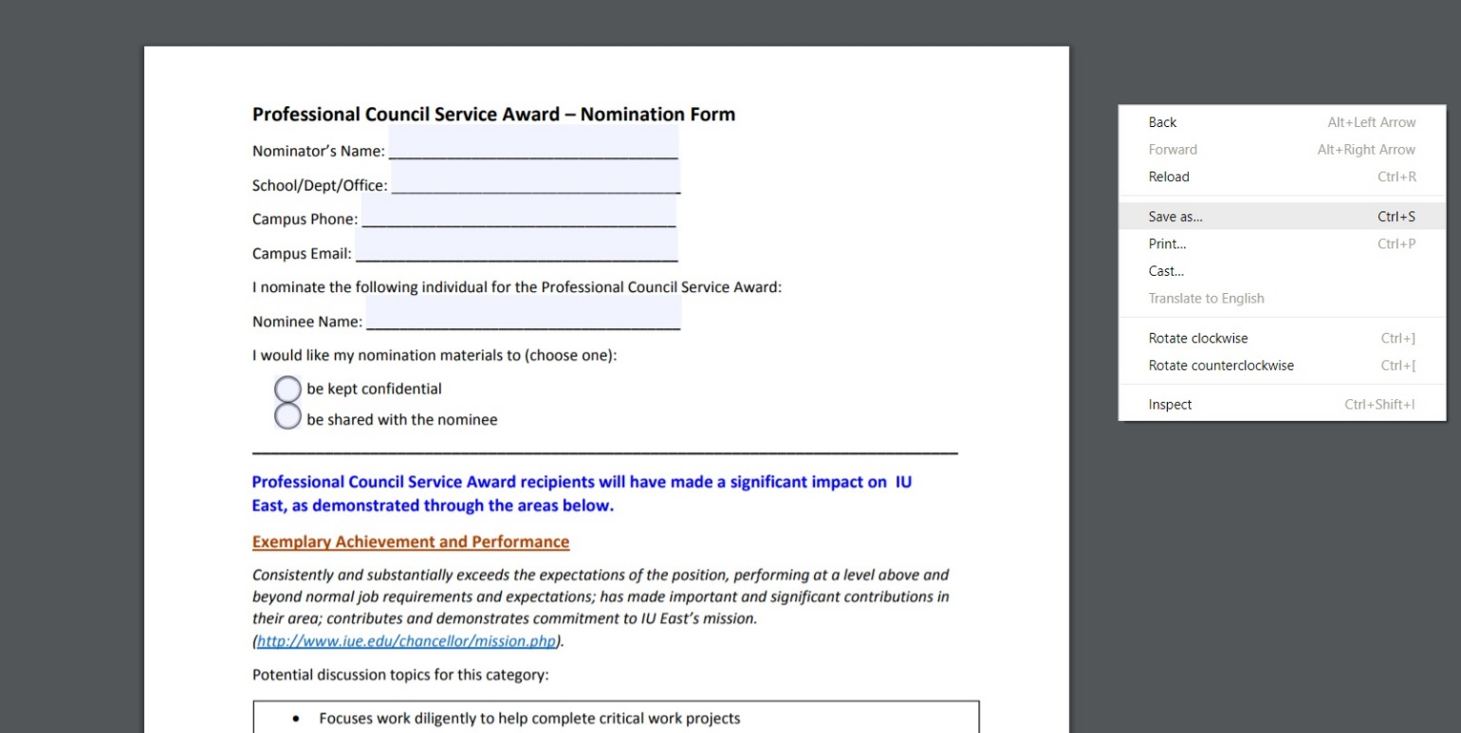
Open the form from the HR website and right click on the screen to click on Save As…

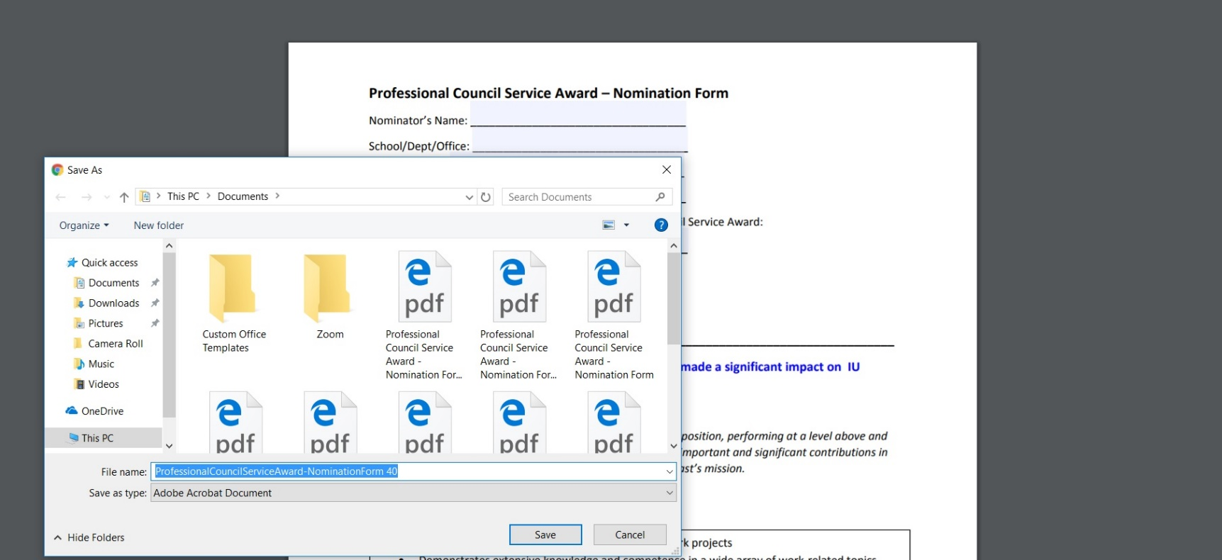
Save as a file name and Adobe Acrobat Document.

Right click to open the file and select open with Adobe Acrobat.

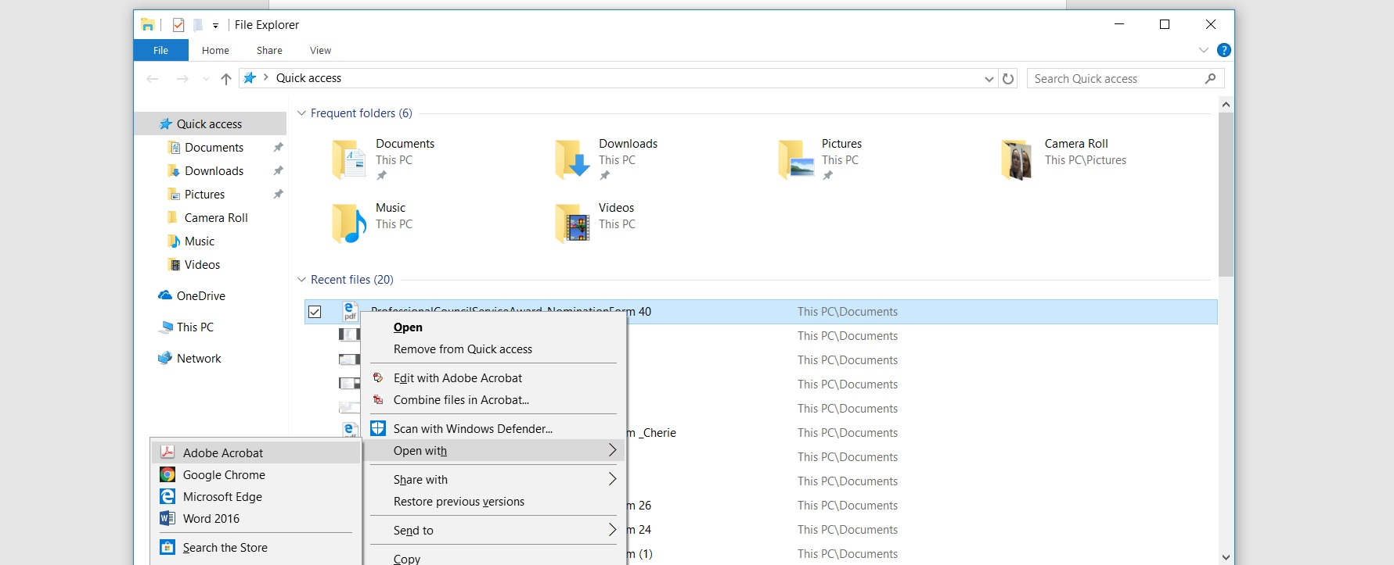

Once in Adobe Acrobat, fill in the pdf.

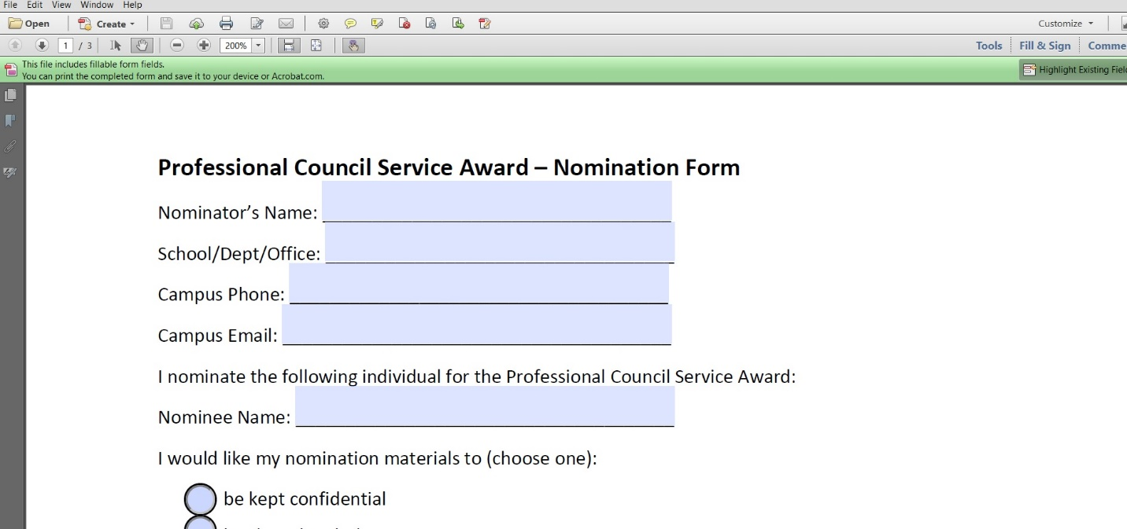

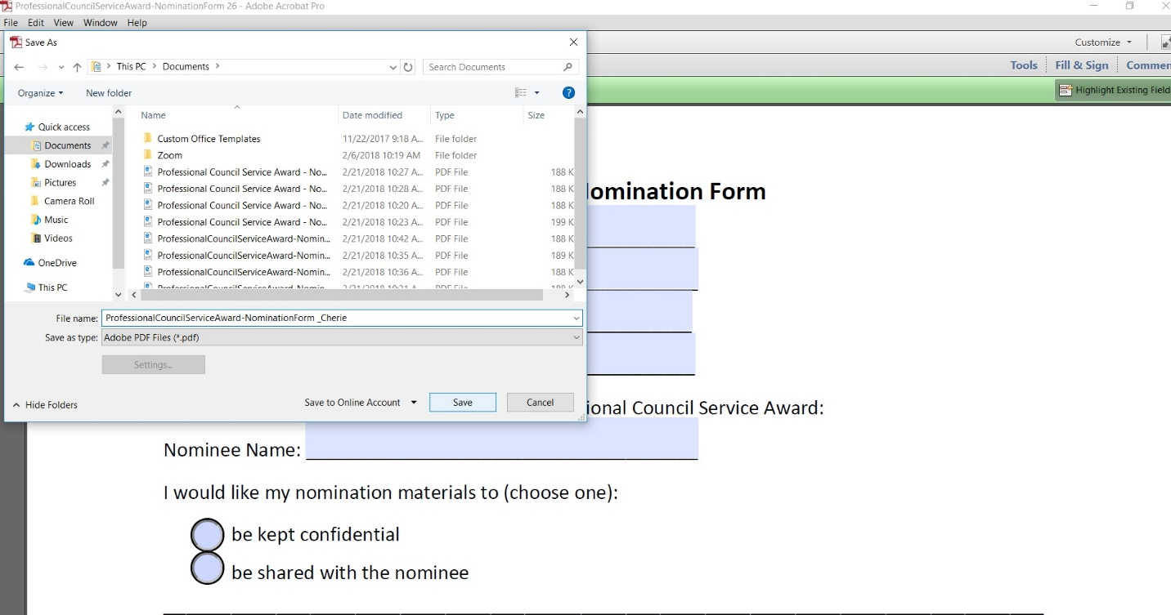
Once filled in, save the file by going to File> Save As>

